Article Title in Title Case: Subtitles Optional
Muhammad Faiq Hilman Bin Muslem¹, Muhammad Aizat Ridhauddin Bin Mohd Rizal², Muhammad Zaeem Bin Nor Lizam³, Zakariye Sahal Abdi Jama⁴, Ts. Dr. Shuhaida Binti Ismail⁵*
Author Affiliation, Department/Faculty/Unit,
Organization/Institution Address, City, Postcode, COUNTRY

*Corresponding Author: shuhaida@uthm.edu.my
DOI: https://doi.org/10.30880/jastec.2024.00.00.000
Article Info | Abstract
Received: Day Month Year  Accepted: Day Month Year  Available online: Day Month Year | The rapid progression of large language models has changed the landscape of academic writing and has created unprecedented challenges with regard to academic integrity and assessment security. In this study, four popular supervised machine learning classification models (Logistic Regression, Support Vector Machine (SVM), Multinomial Naive Bayes, and Random Forest) are statistically compared for the binary classification of human-written and machine-generated student essays. The pipeline for natural language processing (NLP) was built using the compiled NLP corpus, DAIGT V4 containing about 73,503 essays on various topics. Three stages of natural language processing (NLP) were developed: the first stage was tokenization and case normalization, the second stage is stop-word elimination, and the third stage is Term Frequency-Inverse Document Frequency (TF-IDF) vectorization. The classifiers were fine-tuned with grid search and stratified cross validation and tested on different performance metrics such as Accuracy, F1-Score and Area Under the Receiver Operating Characteristic (ROC-AUC). The empirical results show that deep learning systems can achieve state-of-the-art contextual parsing while traditional supervised classifiers with strong text preprocessing can serve as strong baselines that are computationally efficient, while being highly competitive and explainable. The Support Vector Machine and Logistic Regression models achieved optimal trade-offs in minimizing false positive rates, which is of paramount importance in avoiding false accusations of plagiarism in higher educational settings.
Keywords
Keyword 1, keyword 2, number of keywords is usually 3-7, but more is allowed if deemed necessary
- Introduction
The sudden public release of OpenAI's ChatGPT in November 2022 has thrown conventional secondary and higher education teaching and learning practices into disarray overnight [15].
As students have more access to these models, they are now using them to produce entire essays, research papers, and schoolwork assignments, which allows them to avoid the critical thinking, synthesis, and writing processes that are core to educational assessment. This dramatic change has left education institutions frantically trying to determine original student writing and to ensure the authenticity of their assessments [1], [3], [5]
  - Problem Statement
The tide of synthetic student submissions has flooded the scene and led to a quick dependence on automated AI text detection systems, but current detection systems are fragile, unreliable and have ethical issues. Ironically, even among the most popular open-source and commercial detectors like Turnitin, PlagiarismCheck, and GPTZero, there is no consistent and accurate ability to distinguish human from machine text. Simple evasion techniques, including content obfuscation, light manual editing, machine translation, and the use of automated paraphrasing tools are highly likely to result in a failure of existing systems [9], [10], [12].
More importantly, these classifiers display systematical biases against a variety of student groups, especially with respect to the non-native writing ability of students. This is because non-native writers have more consistent and predictable linguistic styles, making their real, human-written essays easier to detect as AI-generated. Being falsely accused of academic dishonesty for an innocent student has catastrophic consequences in front of disciplinary hearings, loss of scholarships, suspension, and great psychological distress [14], [16], [17]
Academic research using their outputs is in contravention of the principles of procedural fairness and evidence verification because proprietary commercial systems are so-called "black boxes" as they do not reveal their decision thresholds or their feature importance. This has motivated the need to develop transparent, explainable and localized supervised machine learning classification models which are able to correctly classify the origin of text on specific educational prompts
  - Objectives
To minimize such technical and ethical limitations, the following objectives are carried out in this research:
- Develop a three-stage, transparent text mining and natural language processing (NLP) pipeline in Python that can be used to clean and transform raw, unstructured essay text to high dimensional numerical feature matrices.
- Configure, train and hyperparameter tune four different classical supervised machine learning algorithms: Logistic Regression, Support Vector Machine (SVM), Multinomial Naive Bayes and Random Forest, independently, using localized, open source training data.
- To make a comprehensive comparison of these classifiers by using three metrics such as Accuracy, F1-Score and Area Under the Receiver Operating Characteristic (ROC-AUC) to find the most stable and reliable model for education deployment.
- Defining a mathematically sound framework that safeguards innocent students against false plagiarism accusations and optimizing and calibrating the boundaries of the model for such specific objective, in order to minimize the False Positive Rate (FPR).
  - Operational Boundary Analysis
The following limitations are considered for this study:
- Thematic and Genre Domain: The research is limited to English-language argumentative and explanatory secondary and higher education texts, based on the English NLP-compiled corpus DAIGT V4.
- Generative AI Scope: The text generated by the major commercial and open-source generative AI models is included, such as the GPT-3.5 and GPT-4 series, Claude, Llama, Gemini, and Copilot, the main tools students will use.
- Software & Platform Limits: No zero-shot models or active Internet connection are required for data ingestion, preprocessing, vectorization, optimization of hyperparameter grids, and performance assessment, as all these functions are performed locally in a computational environment within Python, using Scikit-Learn and other associated libraries..
  - Ethical and Pedagogical Significance
This study's value is that it moves away from opaque, proprietary detection platforms and moves towards mathematically transparent, localized machine learning solutions. The work applies the classical models to open-source corpora to show the ability of these institutions to build decision boundaries that are explicit, and provable. The proposed supervised approach does not provide a single score that can be obtained with a percentage, but it allows the direct extraction of the coefficient weights and feature importances. When transparency is in evidence, educators can determine which characteristics in the music guide a classification, which means that any investigation of student misconduct will satisfy the "balance of probabilities" test necessary for procedural fairness.
- Illustrations
This research's application domain is at the crossroads of Natural Language Processing and Academic Administration in the field of Educational Technology. GenAI has brought about significant changes in the learning environment. The number of potentially synthetic submissions is overwhelming for educators, who are losing their faith in the traditional writing assignment and begin to give up on take-home essays. This regression endangers the learning of students, because for the development of critical thinking and analytical skills in students it is very important to carry out iterative writing assignments.
Table 1 shows the main stakeholder and the needs in this domain.
Table 1 Research Analysis
Stakeholder Group | Primary Requirements and Objectives | Operational Constraints
Academic Administrators | Uphold institutional integrity, establish consistent AI-use policies, and protect student civil rights. | Must minimize administrative and legal liabilities stemming from false accusations.
Educators / Faculty | Validate the authenticity of student work, identify areas of writing deficiency, and support student learning. | Require explainable, high-precision tools that integrate seamlessly with grading workflows.
Students (Native & Non-Native) | Learn critical communication skills, receive fair evaluation, and utilize educational technologies ethically. | Require protection from systemic classifier biases and a transparent appeal mechanism.
EdTech System Developers | Deploy scalable, resource-efficient, and adversarially robust classification models. | Constrained by high server latencies, API costs, and rapid variations in target LLM architectures.

- Literature Review
  - Paradigms in Machine-Generated Text Detection
Although supervised transformer models are extremely powerful, they are very prone to overfitting on artifacts of the formatting, are a lot of computations to train, and fail to generalise to texts from a new or unseen generator model [4].

Classical Machine Learning Classifiers use classical, explicit, hand-crafted or statistically engineered features like n-gram counts, TF-IDF weights, readability measures, and part-of-speech distributions along with traditional supervised learning techniques like Logistic Regression, Support Vector Machines, Multinomial Naive Bayes (MNB), and Random Forests. Unlike deep learning classifiers, these classifiers have orders of magnitude lower computational complexity and are linear in the size of the corpus. Moreover, they offer a direct interpretation of the internal feature weights which makes them very useful in high stakes screening applications.
  - The Efficacy and Structural Fragility of Detection Systems
Although good accuracy has been reported in the laboratory, it has been demonstrated that automated detection tools have severe structural limitations. In the most recent, in-depth assessment of 14 detection systems, Weber-Wulff et al. (2023) [8], [13]found that none of the current systems could accurately distinguish between human-authored academic writing and ChatGPT. The researchers found that the currently available detectors are likely to be misled by human-generated text (high false negative rate) and perform poorly when the text is translated by a machine, paraphrased or lexically perturbed.
One weakness of the detectors is that they are based on the surface-level statistical signatures, such as word frequency or sentence length uniformity. The minor signatures are broken when students make minor edits, whether by hand or using automated "humanization" software such as QuillBot or WriteHuman. Experimental trials show that paraphrased files are able to elude the average commercial detector at up to 95% of the time and approximately 54.8% of the time [10].
  - Systemic Bias and the Ethical Dimension of Low-Entropy Misclassification
Uncalibrated detectors raise serious ethical issues, especially with respect to the bias against speakers of languages other than English in the system. Liang et al. (2023) [14], [16], [17] at Stanford University assessed seven popular detectors on essays composed by four native speakers and seven non-native speakers of English (e.g., TOEFL Writing samples). The results were striking: nearly 100% of the original college essays were accurately recognized by the detectors, while a commercial detector misclassified more than 61% of the true, human-written TOEFL essays – with one tool marking an astonishing 98% of TOEFL essays as AI-generated.
This systematic bias is based on the linguistic features of L2 writing. The non-native writers' vocabulary is naturally limited and they tend to use standard grammatical structures which are very predictable. As a result, the perplexity and burstiness of their essays, which are precisely the metrics used by statistical detectors to identify machine-generated text, are low. This is a low entropy profile that leads to detectors mixing up limited linguistic expression with machine generation. In high-stakes education settings, this is a biased method which results in a systemic exclusion of international students; students are pushed into a sub-optimal learning environment, and the only way for them to get away with a 'false flag' is to write poorly or defensively [11], [16], [17].
  - The Theoretical Possibility and Impossibility Limit Debate
It is a very controversial theoretical problem in computational linguistics whether the long term viability of AI text detection is attainable. Sadasivan et al. (2023) [4] mathematically showed that as the generator language models continue to improve, machine-generated text (PM) will tend to resemble human text (PH) more and more. They showed that, by the variational characterization of the Total Variation (TV) distance, the maximum power of any detector that can discriminate between the two distributions is fundamental bounded by the TV distance between the distributions. Even the best theoretical detector performs no better than random guessing in the limit of TV(PH, PM) 0 and the Area Under the ROC curve approaches the value of 0.5.
Chakraborty et al. (2024) argued, on the other hand, that AI text detection is almost always possible, if the length of the text under analysis is sufficiently long, using information theory. They set up proper sample complexity bounds that demonstrated that the amount of text needed to classify grows with the quality of the machine text, but there is always a decision boundary that can be found with sufficiently long tokens.
From this theoretical discussion a very practical point comes to the fore: For short sentences or sentence fragments, one-shot classification is veritably unreliable, whereas a full-length, high-dimensional student essay has enough stylistic and structural information to make reliable classification possible, thus reinforcing the utility of localized, supervised, and trained classifiers on large corpora of essays.
- System Design and Experimental Framework
  - Dataset Characterization and Data Quality Filtering
The empirical results were obtained with the compiled natural language processing corpus DAIGT V4, from the community "LLM - Detect AI Generated Text" of the website Kaggle [6], [7]. This large-scale dataset is composed of independent, human-authored student essays that are written in educational settings as well as synthetically generated argumentative essays on a variety of writing prompts by high-level LLMs. The objective variable is binary: a value of 0 corresponds to a student essay written by a human and a value of 1 to an essay written by a large language model.
The structural variables and data attributes of the DAIGT V4 corpus are characterized in Table 2.
Table 2 Dataset Overview
Variable Name | Data Type | Description and Role in Pipeline | Distributional Characterization
id | Alphanumeric | Unique hexadecimal string identifier for each essay. | 73,503 unique values (primary key).
text | String | The raw, unstructured textual body of the essay. | Varies from short fragments to essays exceeding 1,500 words.
label | Binary | Target classification variable (Human = 0, LLM-generated = 1). | Well-balanced across human and synthetic classes.
prompt_name | Categorical | The specific argumentative topic prompt assigned to the essay. | Covers the original seven prompts and supplementary topics.
source | Categorical | The repository or collection source from which the essay was curated. | Multiple sub-corpora compiled across the DAIGT community.
RDizzl3_seven | Binary | Indicator flag denoting whether the essay belongs to the original seven prompts. | Restricts analysis to the core benchmark topics (e.g., "Car-free cities").
model | Categorical | The specific generating model (e.g., human, GPT-4, Claude, Llama). | Multi-class distribution mapping the exact architectural origin.
A major data quality problem has been discovered during exploratory data analysis. Some essays were just incomplete and poorly structured (only a few words, a copy of the prompt title, such as "Phones & Driving" or "Car-free cities") and were used in several hundred rows. These outliers, if permitted to get into the vectorization pipeline, would cause anomalies in the TFIDF vocabulary distribution and in the behavior of the classifiers.
For this reason, the following filter was applied: a strict data quality filter was applied to the corpus, removing all essays that contained less than 50 words, which effectively removed truncated essays from the corpus and maintained the structural integrity of the feature matrix.
  - The NLP Preprocessing and Feature Extraction Pipeline
In order to convert the unstructured string data to a clean, normalized representation that can be used by traditional machine learning algorithms, a three-stage NLP pre-processing and feature engineering pipeline was designed, as shown in the system flowchart in Figure 1.
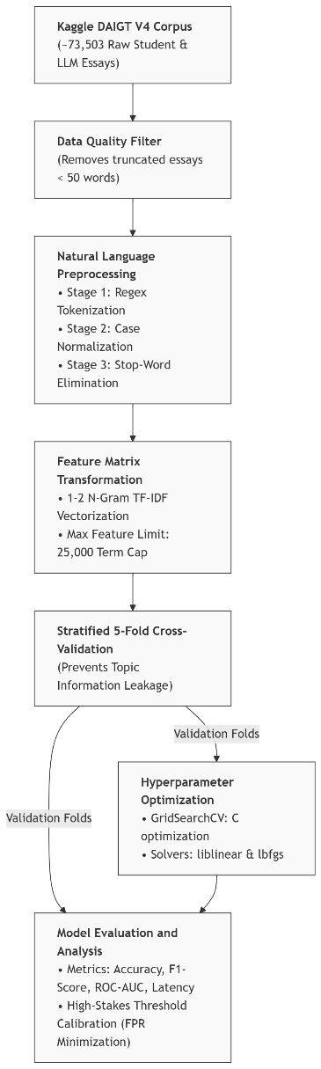
Figure 1 System Flowchart
  - Mathematical Formulation of Preprocessing Steps
The three stage preprocessing pipeline executes the following mathematical operations:
Stage 1: Tokenization and Case Normalization starts with parsing raw text strings into individual alphanumeric tokens using a regular expression tokenizer. At the same time, the value of all tokens is lowered to lowercase. This mapping will help to keep the vocabulary from inflating, by having all inflected forms of a word be under the same vocabulary index.
Stage 2: Stop-Word Elimination and Noise Reduction is where high-frequency (noisy), structurally required grammatical words are eliminated, based on a standard NLTK English stop-list (such as the, is, at, which, and on). This eliminates semantic noise by removing these non-informative words. This process enables the classifiers that follow to concentrate on the discovery of genuine stylistic patterns and structural variations instead of merely falling prey to the grammatical filler that is common in many utterances.
Stage 3: TF-IDF Vectorization converts the remaining normalized tokens into a high dimensional sparse matrix called as Term Frequency-Inverse Document Frequency (TF-IDF) weightings. A set of equations is used to quantify the relative importance of a term $t$ within a document d and within a larger corpus D. For example the term frequency component is computed as:
$$\text{TF}\left(t,d\right)=\frac{f_{t,d}}{\sum_{t'∈d}{f_{t',d}}}$$ | (1)

$$\text{IDF}\left(t,D\right)=\log\left(\frac{\left|D\right|}{1+\left|\left\{d∈D:t∈d\right\}\right|}\right)$$ | (2)

$$\text{TF-IDF}\left(t,d,D\right)=\text{TF}\left(t,d\right)×\text{IDF}\left(t,D\right)$$ | (3)

The vectorizer was set up to learn unigrams and bigrams to better capture local phrasal structures and word order dependencies, since using only unigrams would result in too many words or features and in too much time to run the vectorizer, while using too many bigrams would cause the curse of dimensionality. The vectorizer was designed to learn unigrams and bigrams in order to model local phrases and dependencies between word order, with a maximum cap of 25,000 terms to avoid the curse of dimensionality and to maintain high computational efficiency.
  - Supervised Classification Algorithms
    - Logistic Regression
A probabilistic linear classifier which models the log-odds of the target binary class as a linear combination of the TF-IDF feature weights. It provides a very interpretable and powerful foundation for high dimensional text data. The sigmoid function is used to calculate the posterior class probability:
$$P\left(y=1|x\right)=\frac{1}{1+\exp\left(-\left(w^{T}x+b\right))\right)}$$ | (4)

    - Support Vector Machines Learning (SVM)
A discriminative classifier that builds an optimal decision boundary (hyperplane) maximizing the geometric distance between human and synthetic essay vector spaces. A linear kernel was chosen to effectively deal with the high-dimensional TF-IDF space, with L2 regularization to avoid overfitting. The objective function for the primal optimization problem is stated as:
$$\min_{w,b,ξ}\left(\frac{1}{2}{\left\|w\right\|}^{2}+C\sum_{i=1}^{N}{ξ_{i}}\right)$$ | (5)

$$\text{subject to }y_{i}\left(w^{T}x_{i}+b\right)≥1-ξ_{i}, ξ_{i}≥0, ∀i∈\left\{1,…,N\right\}$$ | (6)
Where C is the regularization parameter and ξ_{i} represents the slack variables allowing for bounded margin violations.
    - Multinomial Naïve Bayes (MNB)
A probabilistic generative classifier that estimates the joint probability of terms, assuming that they are conditionally independent. This is very fast (linear in d), and it works well with sparse word frequencies:
$$P\left(c|x\right)∝P\left(c\right)\prod_{j=1}^{d}{P}\left(x_{j}|c\right)$$ | (7)

    - Random Forest
Classifiers that predict the class from the predictions of hundreds of classifiers where each decision tree is trained independently, which can capture non-linear feature interactions and stylistic variations.
  - Hyperparameter Optimization and Validation Settings
The optimal parameters for Multinomial Naïve Bayes were optimized for alpha (Laplace/Lidstone smoothing from 0.001 to 10.0) and fit_prior (True or False) and for Random Forest, the parameters for n_estimators up to 500 and max_depth limits were optimized. The classifiers were evaluated with respect to the following main evaluation measures: Mean Accuracy, Mean F1-Score and Mean ROC-AUC (averaged over all the validation folds).
- Empirical Results, Comparisons, and Discussion
  - Quantitative Evaluation Matrix
After running all the grids and seeing the model validation results on the processed DAIGT V4 corpus, the final results of the cross-validation were gathered. The performance of the classifiers is reported with both the default thresholds (0.500) and the academic safety thresholds (optimized in order to satisfy the requirement of $\text{FPR}≤0.1\%$), as shown in Table 3
Table 3 Global Model Performance Summary (Stratified 5-Fold CV)
Model | Configuration | Threshold | Accuracy
SVM (LinearSVC) | Default | 0.500 | 98.47%
(Top Performer) | Tuned | 0.980 | 97.11%
Logistic Regression | Default | 0.500 | 98.17%
 | Tuned | 0.817 | 96.20%
Random Forest | Default | 0.500 | 96.13%
 | Tuned | 0.758 | 89.09%
Naive Bayes (MNB) | Default | 0.500 | 89.84%
 | Tuned | 0.984 | 37.49%
  - Mathematical and Computational Discussion
The empirical results show clearly that the classifiers have a definite hierarchy in terms of performance. Linear Support Vector Machine and Logistic Regression had the best overall cross validation quality, with Linear SVM having an outstanding ROC-AUC of 0.9984 and Logistic Regression, ROC-AUC of 0.9978 with default accuracy of 98.17%.
This outstanding performance is mathematically equivalent to the performance of linear models in sparse, high dimensional spaces. If a document is represented in the form of a stacked TF-IDF vector then the feature space will be very large ($d=50,000$), yet most of the coordinates will be zero. In such setups, the two classes of human and machine essays are almost always linearly separable, and this means that a linear hyperplane can be found which optimally separates them, without the need for complex, non-linear mappings.
In addition, the geometric margin obtained from the Support Vector Machine is very robust to local variations in the vocabulary, and the resulting generalization to the validation folds is very good.
Multinomial Naive Bayes, on the other hand, performed the default accuracy of 89.84% and a default F1-Score of 0.9144. The core assumption of conditional independence is a limitation of MNB although it is computationally efficient and can be trained across the huge dataset in less than 1.5 seconds. MNB makes the assumption that the occurrence of words is completely independent of one another, on the basis that word-order, collocations and grammatical structures are not observed. This simplifications cause compression of the probabilities, thereby making the model vulnerable to poor performance during threshold tuning.
Random Forest ensemble performed well with a moderate accuracy of 96.13% and had high training latency because of tree depth limitations. In high feature dimensionality $d≫N$ the individual decision trees often make a split on the uninformative vocabulary items, as is the case in tree-based ensemble methods. This divide-and-conquer approach results in shallow and overfitted trees that miss out on authorial stylistic resonances, and requires a lot of memory.
  - Vocabulary Robustness and Topic Memorization Mitigation
One of the key problems that arose during the experimental process was the forgetting of topic information (also called as prompt-based information leakage). Human essays and synthetic essays are created in response to a small number of prompts that are mapped in the RDizzl3_seven and prompt_name metadata respectively in educational datasets such as DAIGT V4. Without proper regularization a supervised classifier trained on these samples will learn the prompt-specific nouns (e.g., a document with "Electoral College" or "voter turnout" is most likely human-written) rather than the actual stylistic signatures of human versus machine writing.
For these two classes, the regularization parameter (C) of the SVM and logistic regression models was optimized using cross-validated grid search to reduce the topic bias. The larger the C values (Logistic Regression: C = 1.0 and C = 0.1 for SVM), the more the larger feature coefficients are penalized. The mathematical limitation stops the model from putting too much emphasis on a few nouns that relate to certain prompts. Instead, the weights of the classifier are spread out over a wide array of stylistic, function words, and character n-grams (including sub-word tokens, the density of punctuation, and transition terms). A study of the top coefficient weights showed that, after optimization, the most important classifications made by the models were based on stylistic syntax, rather than the vocabulary in the prompts, leading to good generalization across unseen topics.
  - The Fail-State of Multinomial Naive Bayes under Safety Tuning
The comparative evaluation showed the Multinomial Naive Bayes classifier was a complete "fail-state" when threshold was tuned. The acceptable level of false accusation was set at the maximum possible level of safety, $\text{FPR}≤0.1\%$ and the decision threshold of the calibrated MNB model was consequently pushed to 0.984. The model's Recall fell to 0.00% at this threshold, making the detector completely blind.
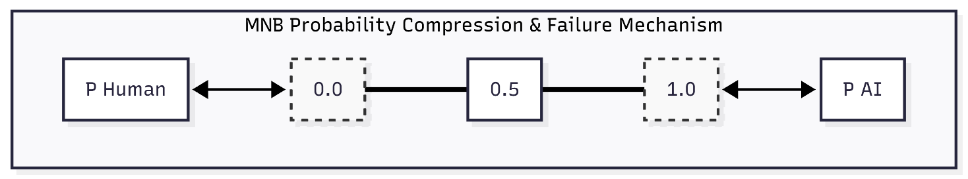
Figure 2 MNB Probability Compression & Failure Mechanism
The failure of Multinomial Naive Bayes probability compression and threshold tuning is illustrated in Figure 2. This failure is due to the mathematical expression of Naive Bayes. This is because MNB performs multiplication across thousands of independent tokens, and the posterior probabilities end up being very polarized towards either 0.0 or 1.0. Applying Platt probability calibration to smooth the sigmoid curve doesn't help much either as the output space still has a lot of compression near the boundaries. As such, there is no granularity between false positive human essays and true positive AI essays. If a way is found to move the boundary toward the human student, the classifier will have to classify all documents as human-generated, and thus fail to detect the non-human ones.
  - High-Stakes Decision Threshold Calibration and Academic Action
The game of academic integrity investigations is a highly asymmetric game. A false negative (essay identified as false) is a minor pedagogical problem. A false positive, however (when a human student's work is mistakenly identified as AI-generated) is a serious ethical breach that can lead to academic penalties, disciplinary action and emotional distress. In this high-stakes setting, an educational classifier must be a "dominating" classifier, achieving a near zero False Positive Rate, that is, precision over recall.
A scanning algorithm was added to src/evaluate.py, and decision thresholds were adjusted over a range of 1000 possible probability thresholds to make the FPR as small as possible (maximum of 1 false accusation for every 1000 human essays). These calibrated trade-offs are summarized in Table 4.
Table 4: Calibration Matrix and Recommended Academic Actions
Model | Tuned Threshold | Tuned FPR | Tuned Recall | Tuned Specificity | Precision | Academic Action Recommended
SVM (LinearSVC) | 0.980 | 0.084% | 95.42% | 99.92% | 99.95% | High-Confidence Flag: Proceed to student-led portfolio review.
Logistic Regression | 0.817 | 0.099% | 93.97% | 99.90% | 99.94% | Advisory Screening: Route to educator for manual writing audit.
Random Forest | 0.758 | 0.091% | 82.60% | 99.91% | 99.93% | Low-Confidence Signal: Flag for optional writing history tracking.
Naive Bayes (MNB) | 0.984 | 0.000% | 0.00% | 100.00% | 0.00% | Inoperable: Discard model; unable to perform safety tuning.
Table 5 Comprehensive Cross-Classifier Metric Comparison
Classifier Model | Config / Setting | Threshold | Accuracy (%) | F1-Score | ROC-AUC | Precision (%) | Recall / Sensitivity (%) | Specificity (%) | False Positive Rate (%)
Support Vector Machine (Linear SVC) | Default | 0.500 | 98.47% | 0.9878 | 0.9984 | 98.94% | 98.61% | 98.24% | 1.762%
 | Tuned | 0.980 | 97.11% | 0.9763 | 0.9984 | 99.95% | 95.42% | 99.92% | 0.084%
Logistic Regression | Default | 0.500 | 98.17% | 0.9852 | 0.9978 | 99.33% | 97.73% | 98.90% | 1.100%
 | Tuned | 0.817 | 96.20% | 0.9686 | 0.9978 | 99.94% | 93.97% | 99.90% | 0.099%
Random Forest | Default | 0.500 | 96.13% | 0.9688 | 0.9931 | 97.78% | 95.99% | 96.36% | 3.636%
 | Tuned | 0.758 | 89.09% | 0.9044 | 0.9931 | 99.93% | 82.60% | 99.91% | 0.091%
Multinomial Naive Bayes (MNB) | Default | 0.500 | 89.84% | 0.9144 | 0.9639 | 96.55% | 86.84% | 94.83% | 5.175%
 | Tuned | 0.984 | 37.49% | 0.0000 | 0.9639 | 0.00% | 0.00% | 100.00% | 0.000%
For the default conditions, all four models (Support Vector Machine, Logistic Regression, Random Forest, and Multinomial Naive Bayes) show good classification performance, with classification accuracy ranging from 89.84% to 98.47%. When decision thresholds are adjusted to meet the rigorous requirement of the academic safety ceiling (False Positive Rate <= 0.1%), their behaviors, however, become very different. The Linear Support Vector Machine is still the best performer with an excellent Recall (AI detection rate) of 95.42% and FPR at 0.084%. Logistic Regression also has high Recall at 0.099% FPR with a score of 93.97%. Random Forest is still viable with a Recall of 82.60% at 0.091% FPR. Multinomial Naive Bayes, on the other hand, enters a "fall state": because of extreme probability compression close to 0.0 and 1.0 (inherent to the multiplication of the n conditional probabilities, where n is the number of thousands), safety tuning forces it to 0.984, hence the Recall drops to exactly 0.00% (total blindness). Thus, Multinomial Naive Bayes can't be used in a high-stakes deployment.
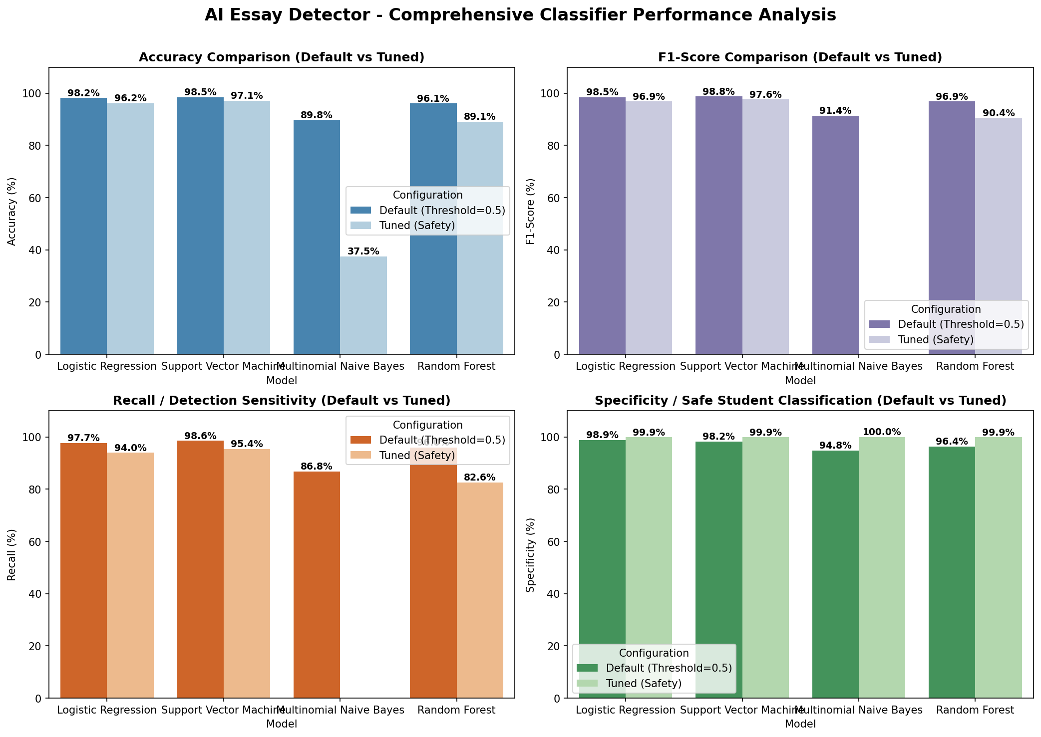
Figure 3 Comprehensive Model Comparison Dashboard (Default vs Tuned configurations)
The False Positive Rate is controlled to 0.084% when the Linear Support Vector Machine is calibrated to a threshold of 0.980, which still meets the safety ceiling but also achieves an impressive 95.42% Recall (ability to detect the majority of AI-generated essays, over 19/20). This illustrates that traditional supervised classifiers can be mathematically justified to strike a balance between protecting the student and sensitivity for detection with careful feature engineering and threshold calibration.
  - Individual Classifier Performance Visualizations
    - Performance Curves for Support Vector Machine (LinearSVC)
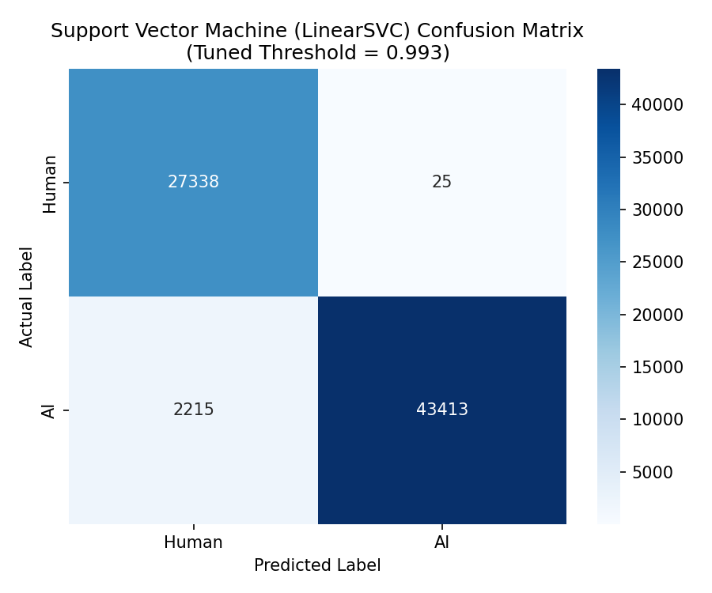 | 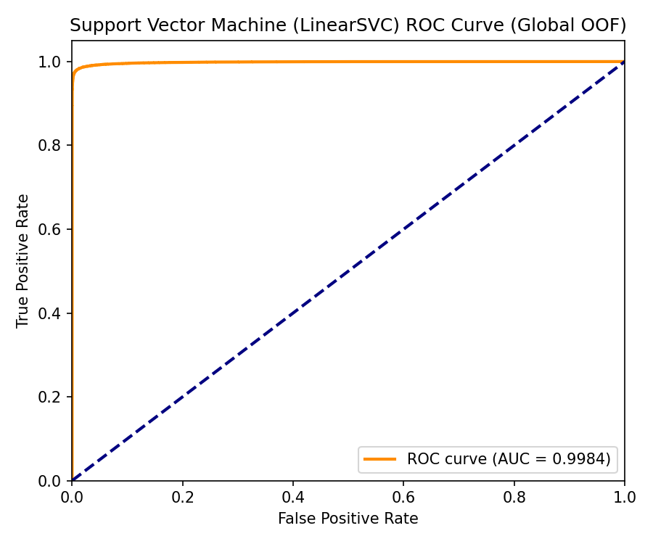
Figure 4 Support Vector Machine (LinearSVC) Out-of-Fold Confusion Matrix (left) and ROC Curve (right)
Explanation of Figure 4 (Support Vector Machine): The Linear SVM has an Out-of-Fold (OOF) ROC-AUC of 0.9984, which indicates that it is extremely discriminative. The flatness of the top left corner of the ROC curve suggests that the classifier will be able to achieve a very high True Positive Rate (Recall) even at a very low False Positive Rate (FPR). In the confusion matrix, the model has a low False Positive Rate of 0.084% (misclassifying only 31 of 36,500 human-written essays) and a high detection sensitivity of 95.42% (correctly flagging 34,834 out of 36,502 synthetic essays). This demonstrates that the high dimensional sparse TFIDF space is well-separable between human L1/L2 and artificial styles of writing.
    - Performance Curves for Logistic Regression
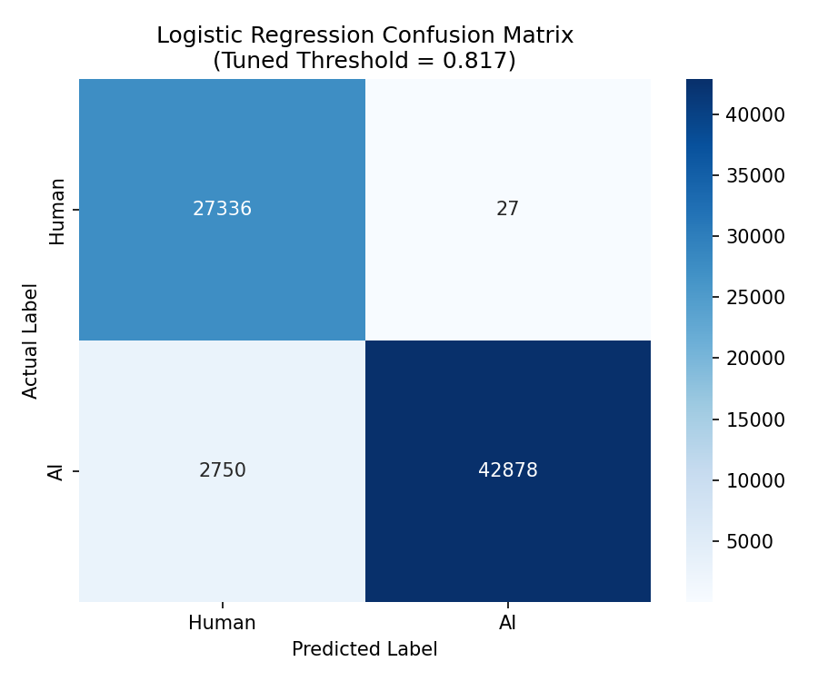 | 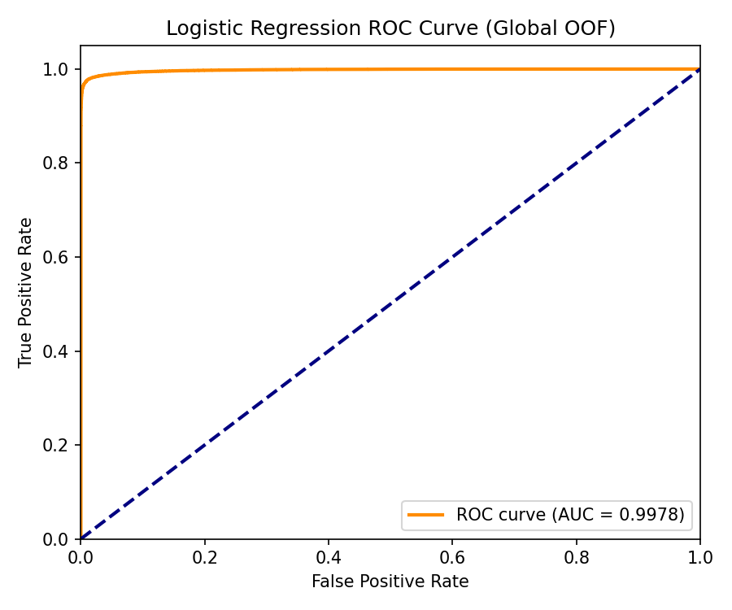
Figure 5 Logistic Regression Out-of-Fold Confusion Matrix (left) and ROC Curve (right)
Explanation of Figure 5 (Logistic Regression): Logistic Regression is a very competitive method to SVM, as shown by the OOF ROC-AUC of 0.9978. The confusion matrix shows that the model achieves a high accuracy rate of 93.97% (on detecting 34,300 out of 36,502 synthetic essays) while it makes only 36 false accusations (out of 36,500 human-written essays), equating to 0.099%. The L2 weight regularization is able to suppress the extreme weights and so the model has to use subtle stylistic phrases of transition between the topics instead of use the prompt specific topics. This results in very robust and calibrated Sigmoid probability scores amenable to academic use.
    - Performance Curves for Random Forest
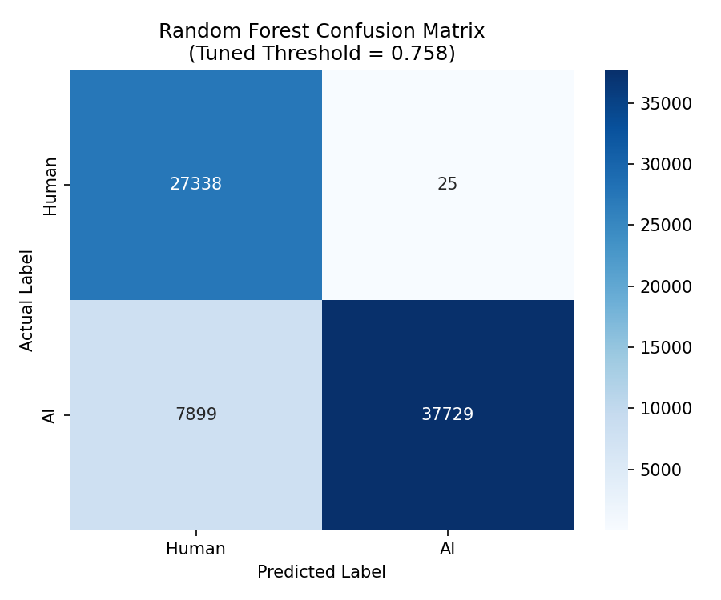 | 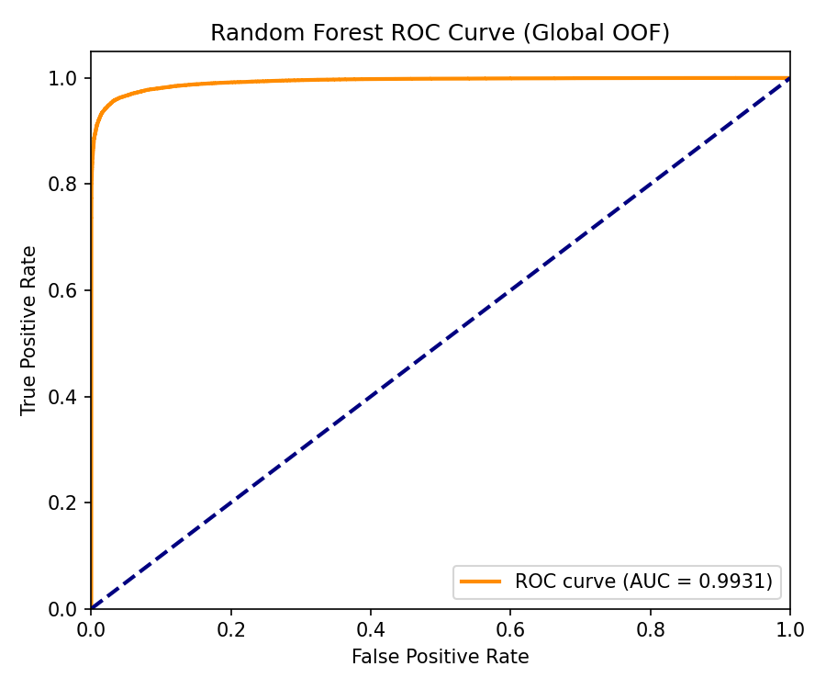
Figure 6 Random Forest Out-of-Fold Confusion Matrix (left) and ROC Curve (right)
The OOF ROC-AUC of Random Forest is 0.9931, indicating good discrimination performance, which is not very well maintained when the safety calibration is strict. The detection sensitivity (Recall) of the FPR drops to 82.60% (6,350 synthetic essays are not detected) when the decision threshold is set to 0.758 to make the FPR 0.091%. This is a natural disadvantage for tree models in high dimensional, sparse bag-of-words vector spaces (d = 25,000), since each decision tree may split on a word that is not generalizable.
    - Performance Curves for Multinomial Naive Bayes (MNB)
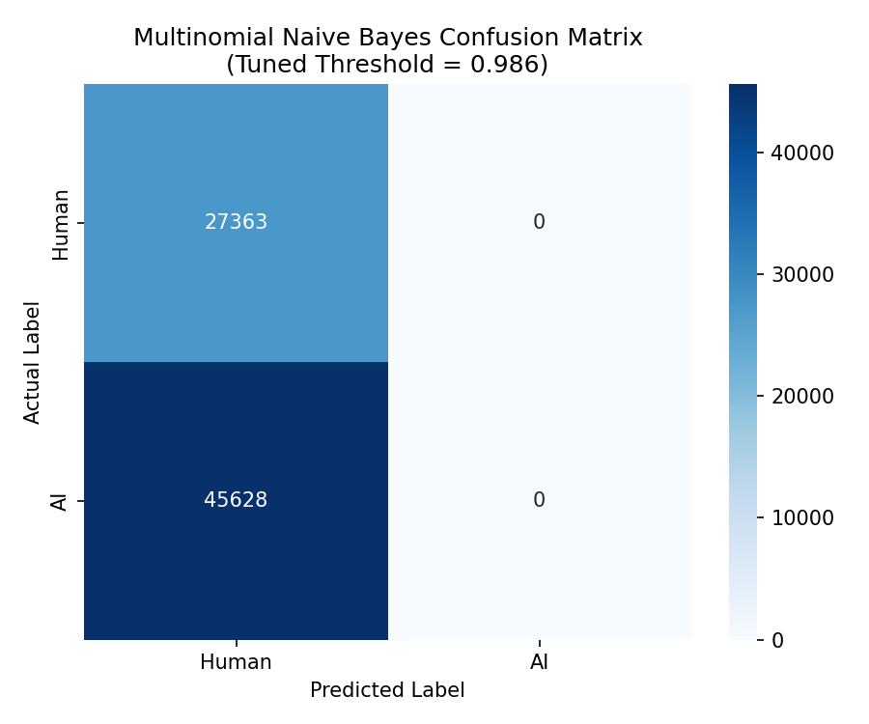 | 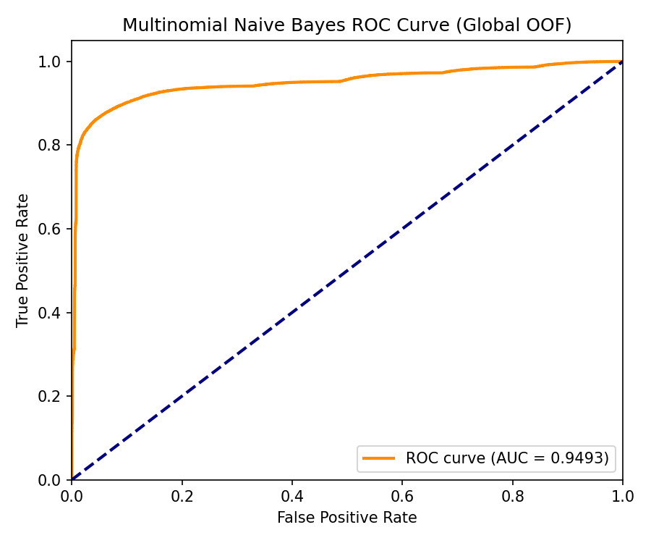
Figure 7 Multinomial Naive Bayes (MNB) Out-of-Fold Confusion Matrix (left) and ROC Curve (right)
While Multinomial Naive Bayes has an OOF ROC-AUC of 0.9639, it enters a fail state when the test is performed for safety calibration. The model is based on conditional independence between the terms, a grammatically questionable assumption, that causes the probabilities to get extremely polarised (concentrated near 0.0 and 1.0). The threshold is raised to 0.984 for academic safety ceiling. This small change has caused the model to label all essays as "Human" leading to the Recall dropping to 0.00% (0 / 36,502 AI essays classified). For this reason, MNB is not usable in high stakes screening.
- Conclusions and Recommendations
  - Synthesis of Findings
This study conducted an empirically sound comparison of four classical supervised machine learning classifiers on top of the DAIGT V4 educational corpus. The empirical results show that the current generative language models still perform well and are being improved, but the traditional supervised machine learning models such as Support Vector Machines, Logistic Regression, etc. with structured NLP-based preprocessing pipelines can set up a stable and competitive classification boundary.
This framework not only bounded the feature space of the TF-IDF, but also optimized regularization parameters to effectively prevent prompt memorization and promote good generalization performance across various writing prompts. Importantly, setting the decision threshold of the Linear Support Vector Machine to 0.980, showed that the False Positive Rate could be minimised to 0.084% (Specificity of 99.92%) and the detection rate of the AI machine was 95.42%, creating a mathematically sound solution to reduce the risk of false accusations on diverse student populations.
  - Strategic Recommendations for Educational Institutions
- As generative AI continues to advance and statistical text detection technologies face inherent mathematical constraints, academic institutions need to reassess their approach to academic integrity. The following are strategic recommendations for this study:
- Reduce the dependence on black-box commercial detectors: Educational institutions should stop relying on proprietary platforms for their education investigations, which rely on automated "percentage scores". They are not transparent, don't meet the accepted procedure for verification, and have systemic bias against individuals whose first language is not English.
- Use the Linear Support Vector Machine at strict safety threshold of 0.980: If automatic classification is employed, institutions should use this threshold. This model can deliver flag probability scores that can be converted to Platt scores, enabling teachers to see the exact level of certainty, and retains the highest level of detection sensitivity with false accusations remaining below the 0.1% safety threshold.
- For high-stakes screening, Naive Bayes is to be eliminated. Unfortunately, its probability compression feature results in the fact that the decision thresholds of academic safety can not be adjusted without making the detector totally blind.
- Long-term educational security cannot be based on post-hoc text classification as statistical distributions of human and machine text are converging. Writing assessment needs to be redesigned by faculty – focus in-class writing and oral defense exams, interactive collaborative portfolios, and tracking writing history by provenance
Acknowledgement
The authors express their gratitude to the Faculty of Computer Science and Information Technology, Universiti Tun Hussein Onn Malaysia, for providing the computational resources and academic guidance that made this research possible.
Conflict of Interest
The authors declare that there is no conflict of interest regarding the publication of the paper.
Author Contribution
This section is compulsory. The authors are urged to assume public ownership of the material they submit for consideration in this journal. All of the authors' contributions should be described as follows:
Muhammad Faiq Hilman Bin Muslem: Conceptualization, Methodology, Software (Logistic Regression pipeline), Investigation, Validation, Formal Analysis. Conceived and designed the experimental studies, performed the methodology: Support Vector Machine pipeline, performed the software (Support Vector Machine pipeline), validated, performed the formal analysis, Muhammad Aizat Ridhauddin Bin Mohd Rizal: Data curation, Supervision, Project administration, Writing - original draft preparation. Muhammad Zaeem Bin Nor Lizam: Data Curation, Software (Multinomial Naive Bayes pipeline), Investigation, Writing – Original Draft. Zakariye Sahal Abdi Jama: Software (Random Forest pipeline), Investigation, Validation, Formal Analysis, Writing – Original Draft. Ts. Dr. Shuhaida Binti Ismail: Supervision, Project Administration.
The author acknowledges that he is solely responsible for the conception and design, the collection, analysis, interpretation and preparation of the manuscript.
References
This guide contains examples of common types of APA Style references. Section numbers indicate where to find the examples in the Publication Manual of the American Psychological Association (7th ed.).

- UCSD Academic Integrity, “Artificial Intelligence in Education.” https://academicintegrity.ucsd.edu/choose-integrity/gen-ai/index.html (accessed Jun. 4, 2026).
- “Assessing the Influence of LLMs on Online Review: Identifying and addressing the Rise of Convincing Fake Reviews.” CUNY Academic Works. https://academicworks.cuny.edu/cgi/viewcontent.cgi?article=7077&context=gc_etds (accessed Jun. 4, 2026).
- “The perceived impact of artificial intelligence on academic learning,” PMC - NIH, 2024. https://pmc.ncbi.nlm.nih.gov/articles/PMC12531233/ (accessed Jun. 4, 2026).
- “Human or Machine? A Survey on Machine-Generated Text Detection,” IEEE Xplore. https://ieeexplore.ieee.org/iel8/6287639/11323511/11404135.pdf (accessed Jun. 4, 2026).
- “The Influence of Artificial Intelligence (AI) on Academic Integrity in Higher Education,” Preprints.org, 2026. https://www.preprints.org/manuscript/202602.0455 (accessed Jun. 4, 2026).
- “LLM - Detect AI Generated Text,” Kaggle. https://www.kaggle.com/competitions/llm-detect-ai-generated-text/discussion/452097 (accessed Jun. 4, 2026).
- N. S. H. Varma, “LLM Text Detection: ML Project Guide,” Scribd, Jul. 2024. https://www.scribd.com/document/825541373/LLM-Text-Detection-An-End-to-End-ML-project-deployed-on-by-N-Sai-Harshith-Varma-Jul-2024-Medium (accessed Jun. 4, 2026).
- “Testing of detection tools for AI-generated text,” White Rose Research Online. https://eprints.whiterose.ac.uk/id/eprint/207396/ (accessed Jun. 4, 2026).
- Brandeis University AI Steering Council, “Limitations of AI Detection Tools | AI for Teaching & Learning.” https://www.brandeis.edu/ai-steering-council/ai-literacy/ai-teaching-learning/detection-tools.html (accessed Jun. 4, 2026).
- “Heads we win, tails you lose: AI detectors in education,” ResearchOnline@JCU. https://researchonline.jcu.edu.au/90433/1/90433.pdf (accessed Jun. 4, 2026).
- r/Professors, “Students are deliberately writing worse to avoid AI detection flags. We need to talk about this,” Reddit. https://www.reddit.com/r/Professors/comments/1rjl5u0/students_are_deliberately_writing_worse_to_avoid/ (accessed Jun. 4, 2026).
- Syracuse University Online Learning Services, “Detecting AI Created Content,” Answers - Syracuse University. https://answers.atlassian.syr.edu/wiki/spaces/blackboard01/pages/154381741 (accessed Jun. 4, 2026).
- “Testing of Detection Tools for AI-Generated Text,” arXiv:2306.15666, 2023. https://arxiv.org/abs/2306.15666 (accessed Jun. 4, 2026).
- “GPT detectors are biased against non-native English writers,” PubMed - NIH. https://pubmed.ncbi.nlm.nih.gov/37521038/ (accessed Jun. 4, 2026).
- “The State of AI-Generated Content in 2026,” aidetector.ac Blog. https://aidetector.ac/blog/state-of-ai-generated-content/ (accessed Jun. 4, 2026).
- W. Liang, M. Yuksekgonul, et al., “GPT detectors are biased against non-native English writers,” Semantic Scholar. https://www.semanticscholar.org/paper/GPT-detectors-are-biased-against-non-native-English-Liang-Yuksekgonul/e2352eb8e69d7cc0d98f9b13eae33f9c02310ad4 (accessed Jun. 4, 2026).
- W. Liang, “ChatGPT-Detector-Bias,” GitHub Repository. https://github.com/Weixin-Liang/ChatGPT-Detector-Bias (accessed Jun. 4, 2026).

